**Name : Chandana Ramesh Galgali Roll Number : 16010422234 Batch : B-4**

**Tutorial - 9**

**______________________________________________________________________________**

**Code:**

**import React, { useState } from 'react';**

**import './App.css';**

**import ocean_breeze from 'C:/Users/chand/Downloads/ReactJS/my-app/src/perfumes/ocean_breeze.jpg';**

**import floral_embrace from 'C:/Users/chand/Downloads/ReactJS/my-app/src/perfumes/floral_embrace.jpg';**

**import citrus_spark from 'C:/Users/chand/Downloads/ReactJS/my-app/src/perfumes/citrus_spark.jpg';**

**import spicy_rhythm from 'C:/Users/chand/Downloads/ReactJS/my-app/src/perfumes/spicy_rhythm.jpg';**

**const perfumes = [**

**{ id: 1, name: "Ocean Breeze", description: "A fresh oceanic scent with hints of salt and sand.", image: ocean_breeze },**

**{ id: 2, name: "Floral Embrace", description: "Bouquet of spring flowers, with dominant notes of lavender and rose.", image: floral_embrace },**

**{ id: 3, name: "Citrus Spark", description: "Energetic aromas of orange and lemon, paired with a hint of mint.", image: citrus_spark },**

**{ id: 4, name: "Spicy Rhythm", description: "Warm and inviting, with notes of cinnamon and vanilla.", image: spicy_rhythm }**

**];**

**function App() {**

**const [selectedPerfume, setSelectedPerfume] = useState(null);**

**const handleSelectPerfume = (perfume) => {**

**setSelectedPerfume(perfume);**

**};**

**return (**

**<div className="App">**

**<header className="App-header">**

**<h1>Scent Haven</h1>**

**<p>Welcome to Scent Haven, where your perfect scent awaits you!</p>**

**</header>**

**<div className="perfume-list">**

**{perfumes.map((perfume) => (**

**<div key={perfume.id} className="perfume-item" onClick={() => handleSelectPerfume(perfume)}>**

**<img src={perfume.image} alt={perfume.name} style={{ width: "100px", height: "150px" }} />**

**<h2>{perfume.name}</h2>**

**<p>{perfume.description}</p>**

**</div>**

**))}**

**</div>**

**{selectedPerfume && (**

**<div className="perfume-details">**

**<h2>Details for: {selectedPerfume.name}</h2>**

**<p>{selectedPerfume.description}</p>**

**</div>**

**)}**

**</div>**

**);**

**}**

**export default App;**

**CSS FILE**

**.App {**

**text-align: center;**

**}**

**.App-header {**

**background-color: #282c34;**

**min-height: 150px;**

**display: flex;**

**flex-direction: column;**

**align-items: center;**

**justify-content: center;**

**font-size: calc(10px + 2vmin);**

**color: white;**

**}**

**.perfume-list {**

**display: flex;**

**flex-wrap: wrap;**

**justify-content: center;**

**padding: 20px;**

**}**

**.perfume-item {**

**margin: 10px;**

**padding: 20px;**

**border: 1px solid #ccc;**

**border-radius: 8px;**

**width: 200px;**

**cursor: pointer;**

**}**

**.perfume-item:hover {**

**border-color: #888;**

**}**

**.perfume-details {**

**margin-top: 20px;**

**}**

**.perfume-item img {**

**border-radius: 5px;**

**margin-bottom: 10px;**

**}**

**______________________________________________________________________________**

**Output:**

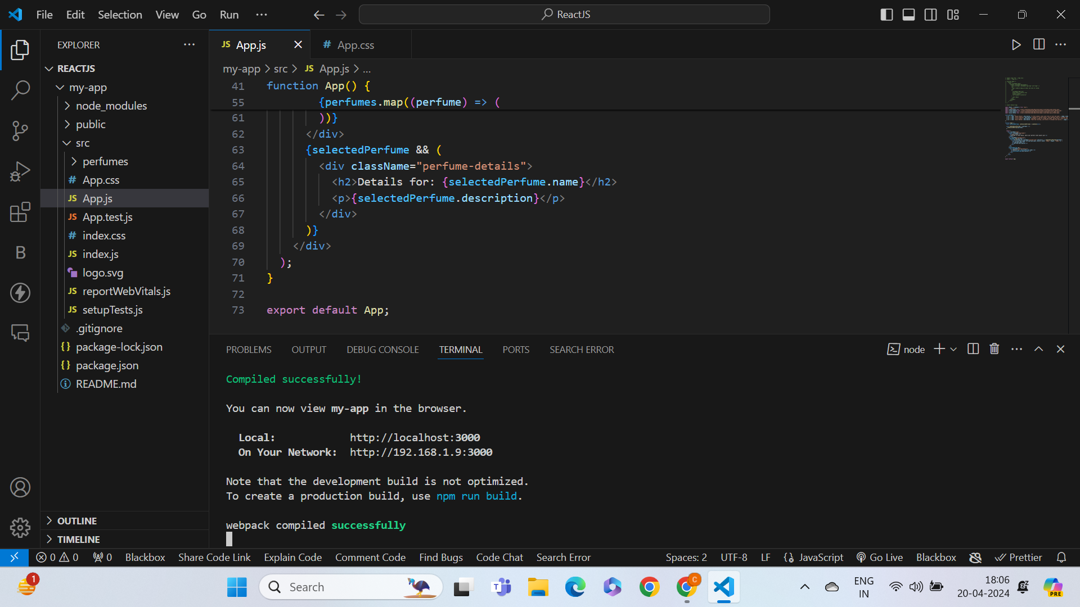

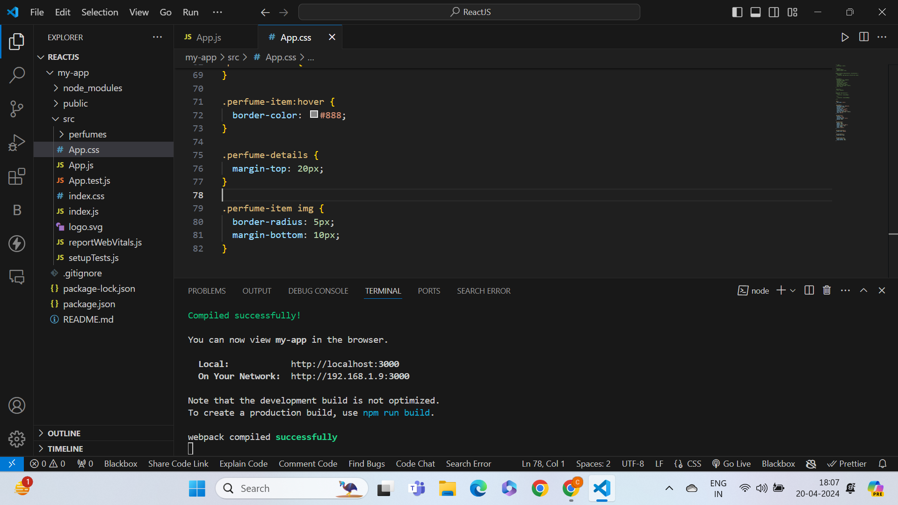

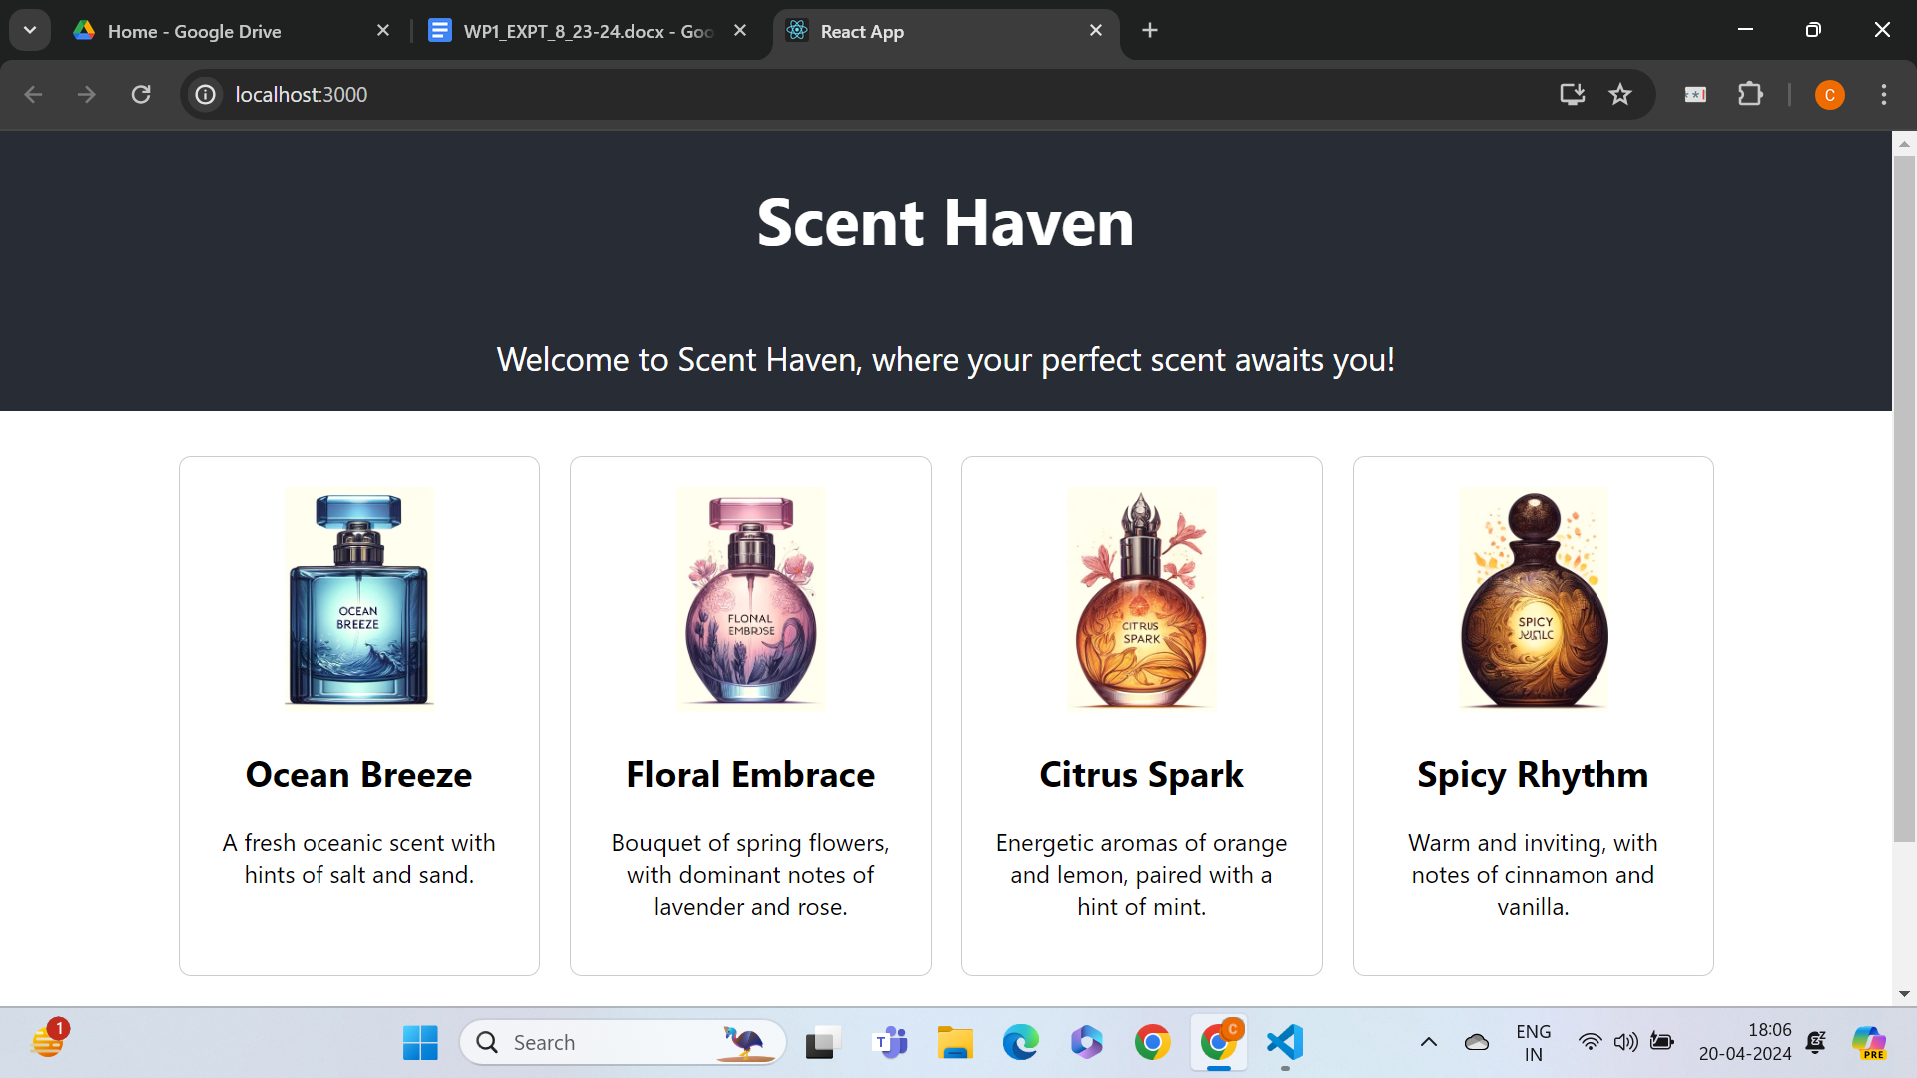

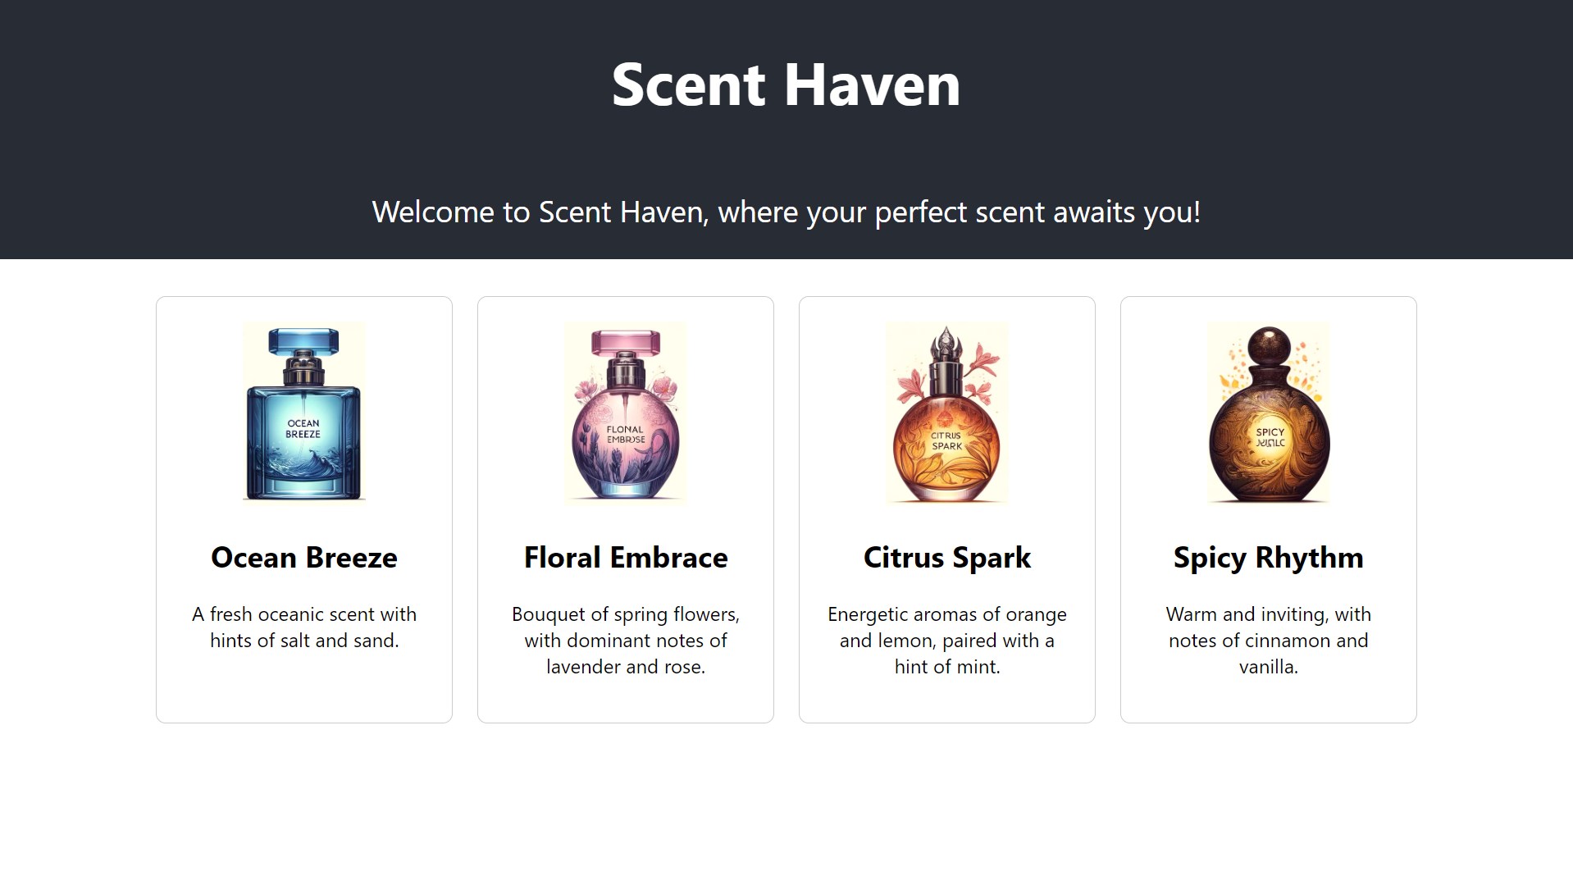

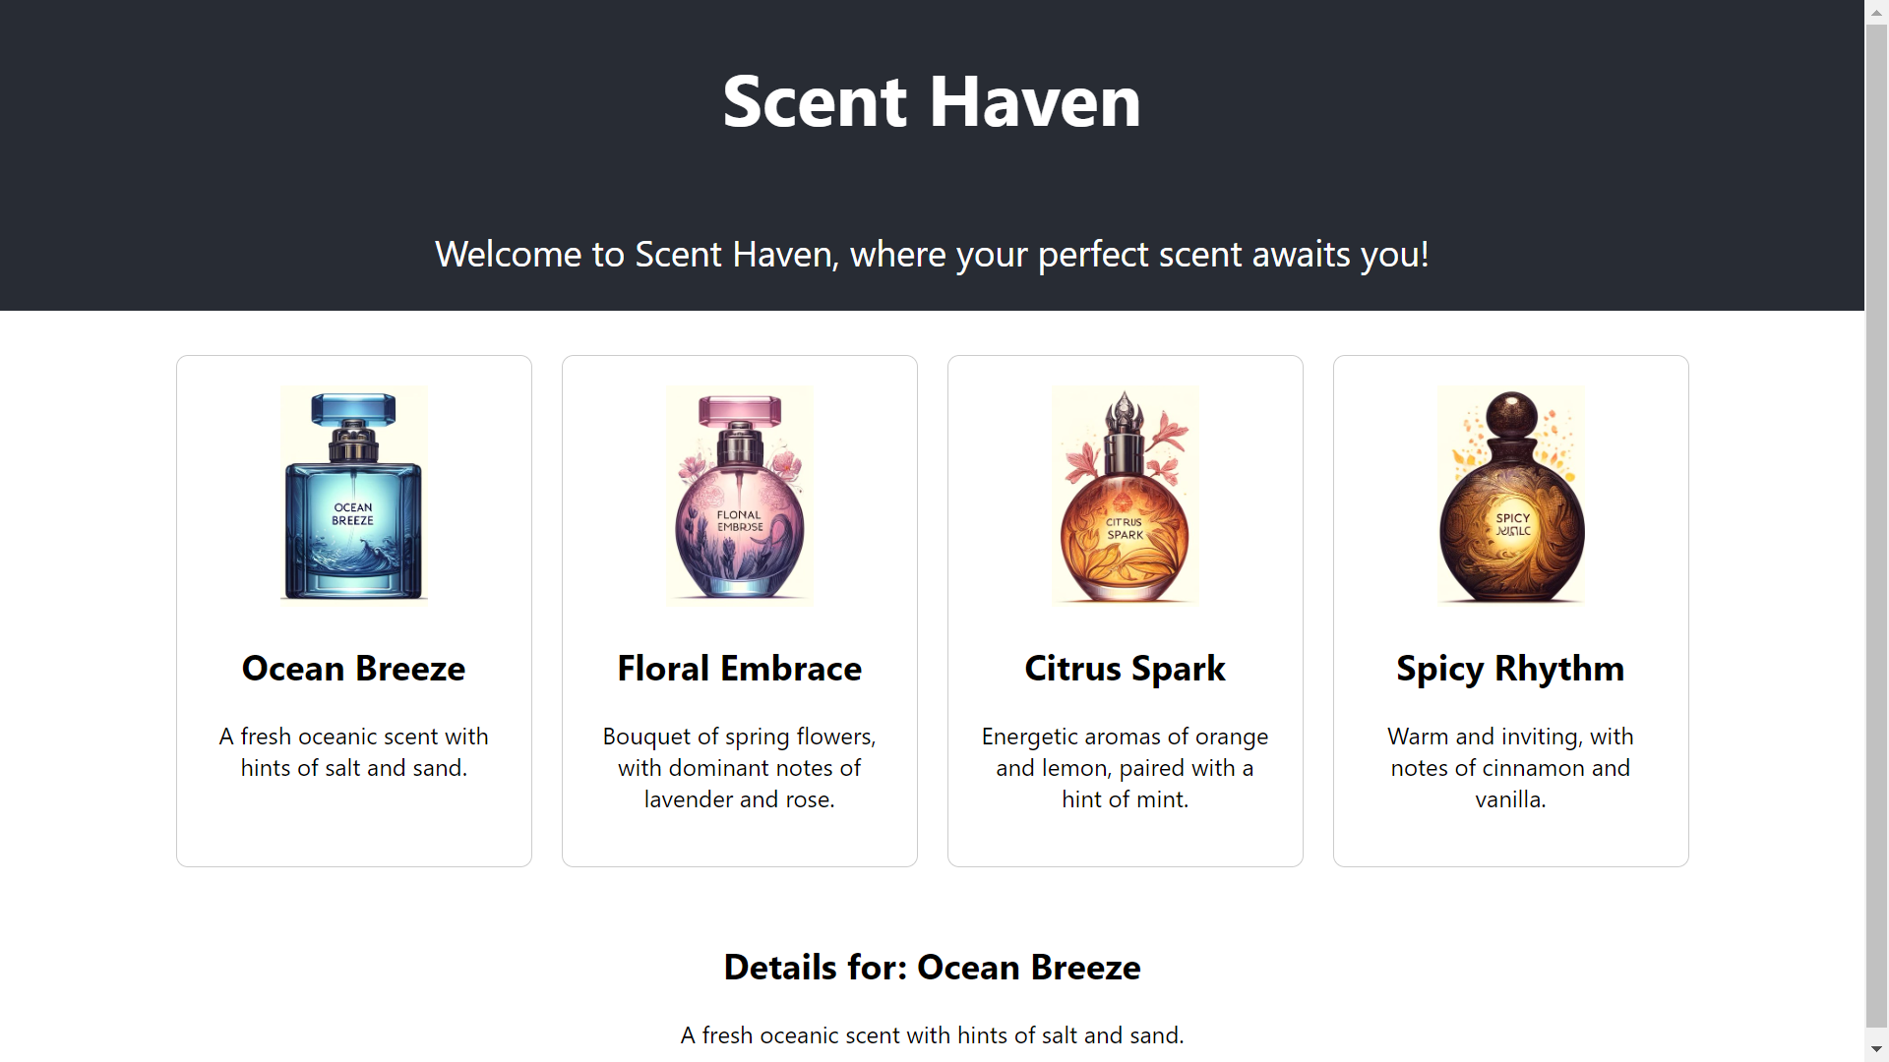

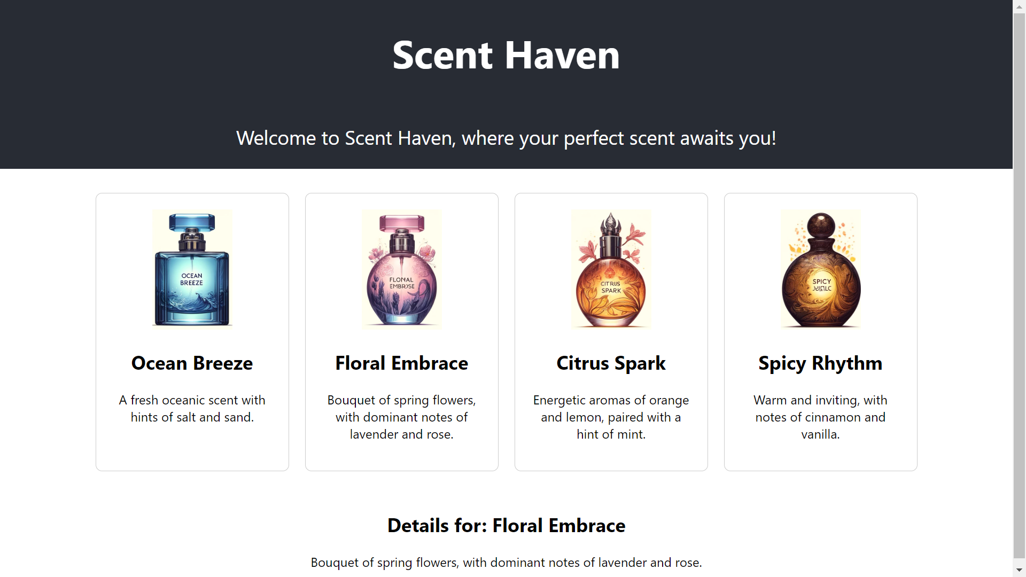

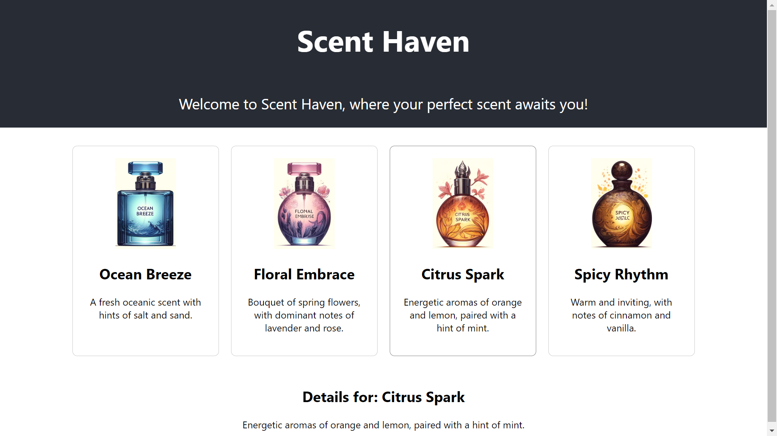

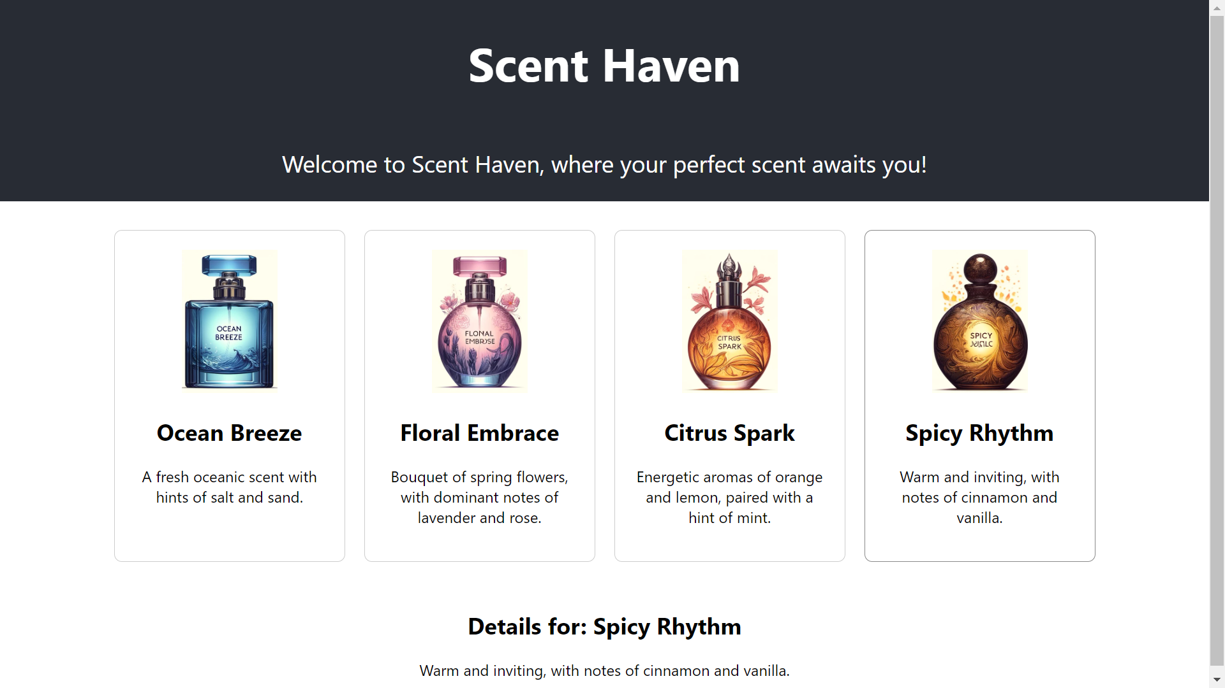

**JS FILE**

**import React, {Component} from 'react';**

***class* App extends React.*Component* { *constructor*(*props*) {**

**super(*props*); this.state = {**

**companyName: ''**

**};**

**}**

**changeText(*event*) { this.setState({**

**companyName: *e***

**______________________________________________________________________________**

**Questions:**

**1. Explain React Components and how it is created and used.**

**Ans:** In React, components are the building blocks of UI. They are reusable, independent pieces of code that render a part of the UI. React components can be classified into two types: class components and functional components.

1. Class Components:

Class components are ES6 classes that extend from React.Component. They have a render() method that returns the UI to be rendered. Here's an example:

import React, { Component } from 'react';

class Welcome extends Component {

render() {

return <h1>Hello, {this.props.name}</h1>;

}

}

// Usage:

<Welcome name="Alice" />;

2. Functional Components:

Functional components are simply JavaScript functions that return JSX. They are easier to read, write, and test compared to class components. Here's an example:

import React from 'react';

function Welcome(props) {

return <h1>Hello, {props.name}</h1>;

}

// Usage:

<Welcome name="Bob" />;

**2. Explain Hooks and show an example for the same.**

**Ans:** React Hooks are functions that let you use React state and lifecycle features from functional components. They were introduced in React 16.8 to address some limitations of class components and to encourage the use of functional components. Hooks provide a way to reuse stateful logic without changing the component hierarchy.

Here's an example of a simple counter component using the useState hook:

import React, { useState } from 'react';

function Counter() {

// Declare a state variable named "count" initialized to 0

const [count, setCount] = useState(0);

return (

<div>

<p>Count: {count}</p>

<button onClick={() => setCount(count + 1)}>Increment</button>

<button onClick={() => setCount(count - 1)}>Decrement</button>

</div>

);

}

// Usage:

<Counter />;

In this example:

useState is a hook that lets you add React state to a functional component. It returns an array with two elements: the current state value and a function to update that value.

count is the current state value, and setCount is the function to update it.

We render the current count and two buttons to increment and decrement the count.

Hooks allow you to use state and other React features without writing a class. They also enable you to reuse stateful logic across components.

**______________________________________________________________________________**

**Outcomes:** Apply JavaScript and JSON for Web Application development

**______________________________________________________________________________**

**Conclusion: (Conclusion to be based on the outcomes achieved)**

The experiment highlighted the power and effectiveness of React in building modern web applications by showcasing the seamless integration of components, hooks, and props to create dynamic, interactive, and maintainable user interfaces. This knowledge can be further applied and expanded upon in the development of more complex React applications.

**______________________________________________________________________________**